1st step
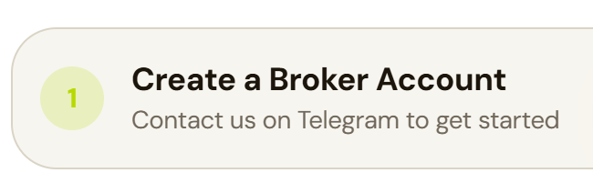

Create a broker account ki jaga
create your account
neechay contact us on telegram ki jaga
create quotex or tradowix account

2nd step
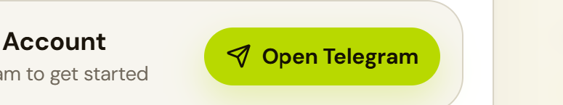

open telegram ki jaga quotex ka link or agar dono ka link add ho sakta hy to dono ka warna phir quotex ka add kr dena
https://broker-qx.pro/sign-up/?lid=2103061 quotex

https://tradowix.com/register?lid=56627618 tradoWix

3rd step
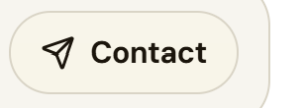

https://t.me/mna_trader_1 telegram inbox
4th step

v1.0 kr den
5th step
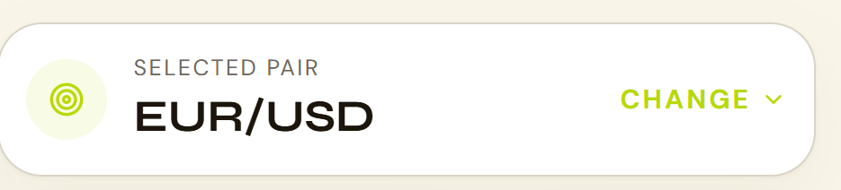
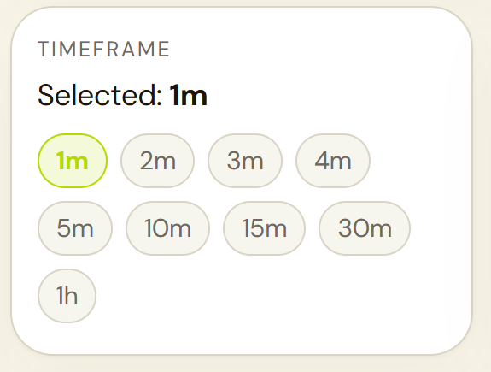
in dono boxes ko

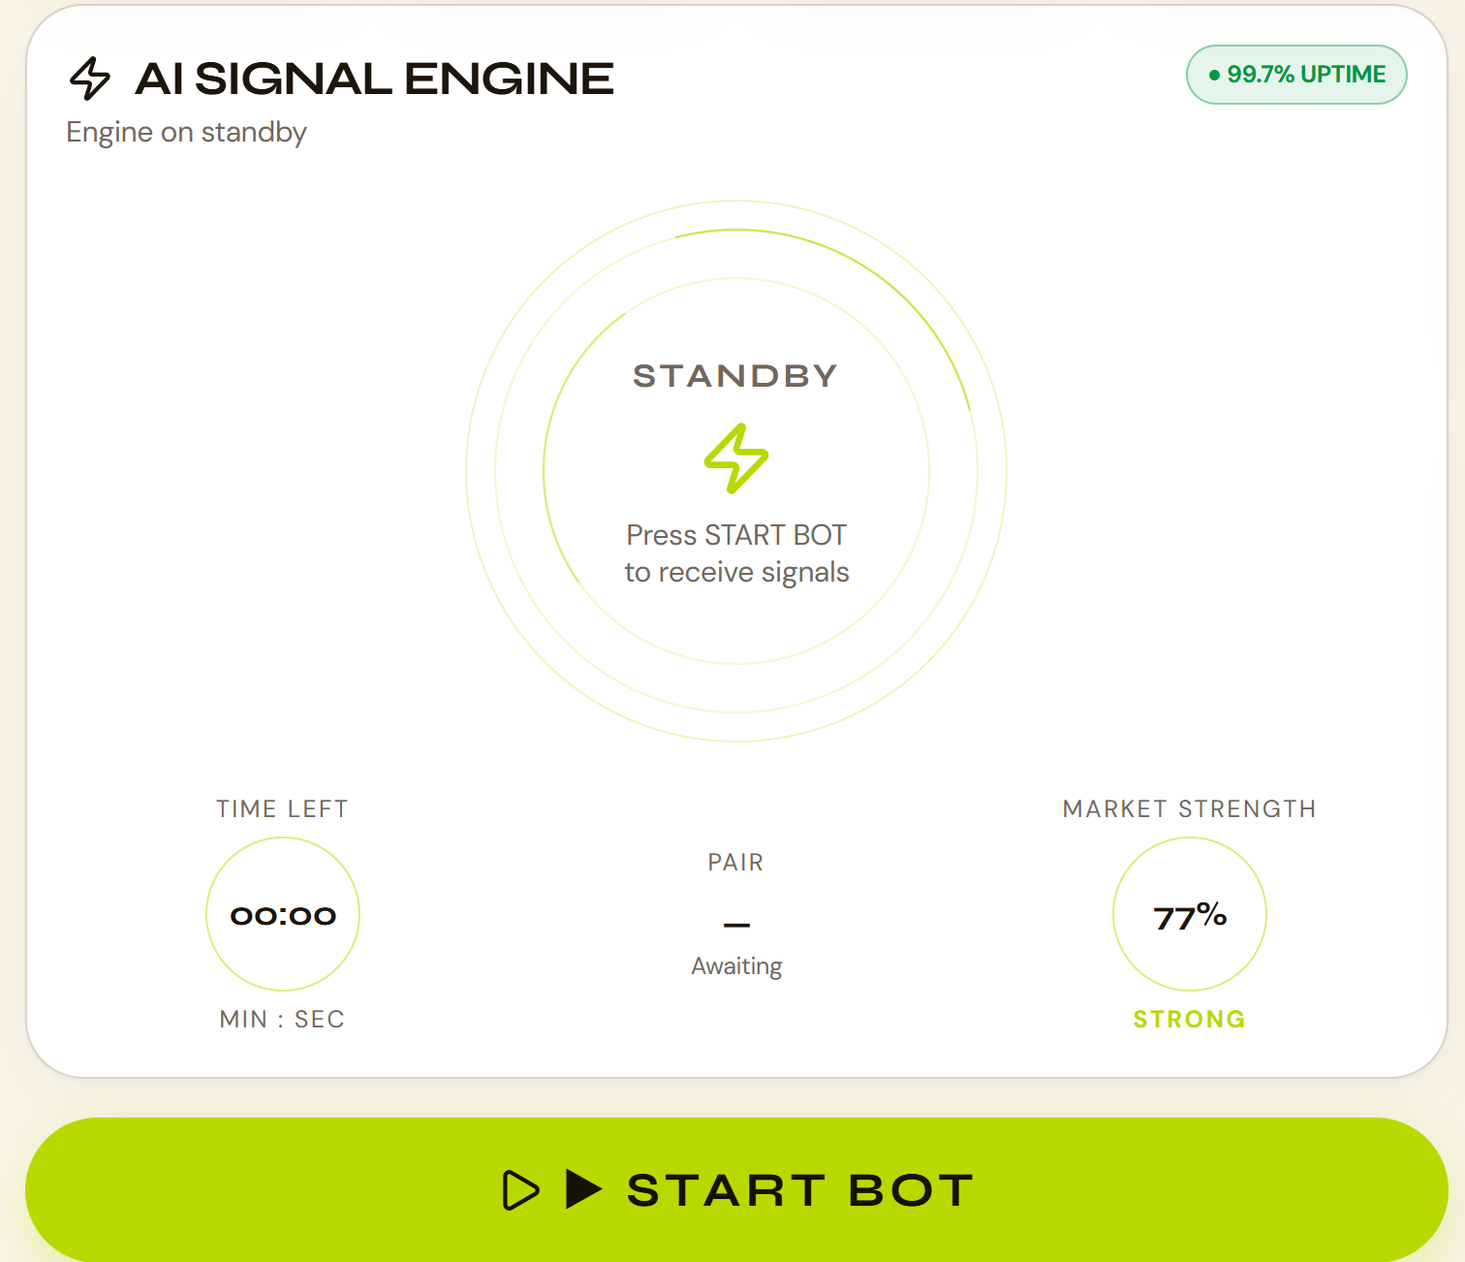
is box ky oper krna hy
or jab start bot pr press kro to direct signal na dy 1 chota sa new box open ho us my neechay candels ka chat sa bana ho or oper scaner chalay left to right and right to left or phir 4 sy 5 second wo scanner chalay phir bot signal dy
oper ai signal engine likha us ki jga ai signal bot or engine on standby ki jaga bot is ready. Or centre my standby ki jaga ready. press strat bot to receive signals ki jaga press GET SIGNAL to recive signal. Green STRAT BOT ki jaga GET SIGNAL. start bot ky neechay chota sa likha hy activate quantum engine uder link den active ai signal bot. Or timer or market strenth ky centre my pair ka option hy wo change ni hota line hi lagi rehti pair select krnay ky baad bi or jab start bot pr press kro to phir pair show hota hy

6th step
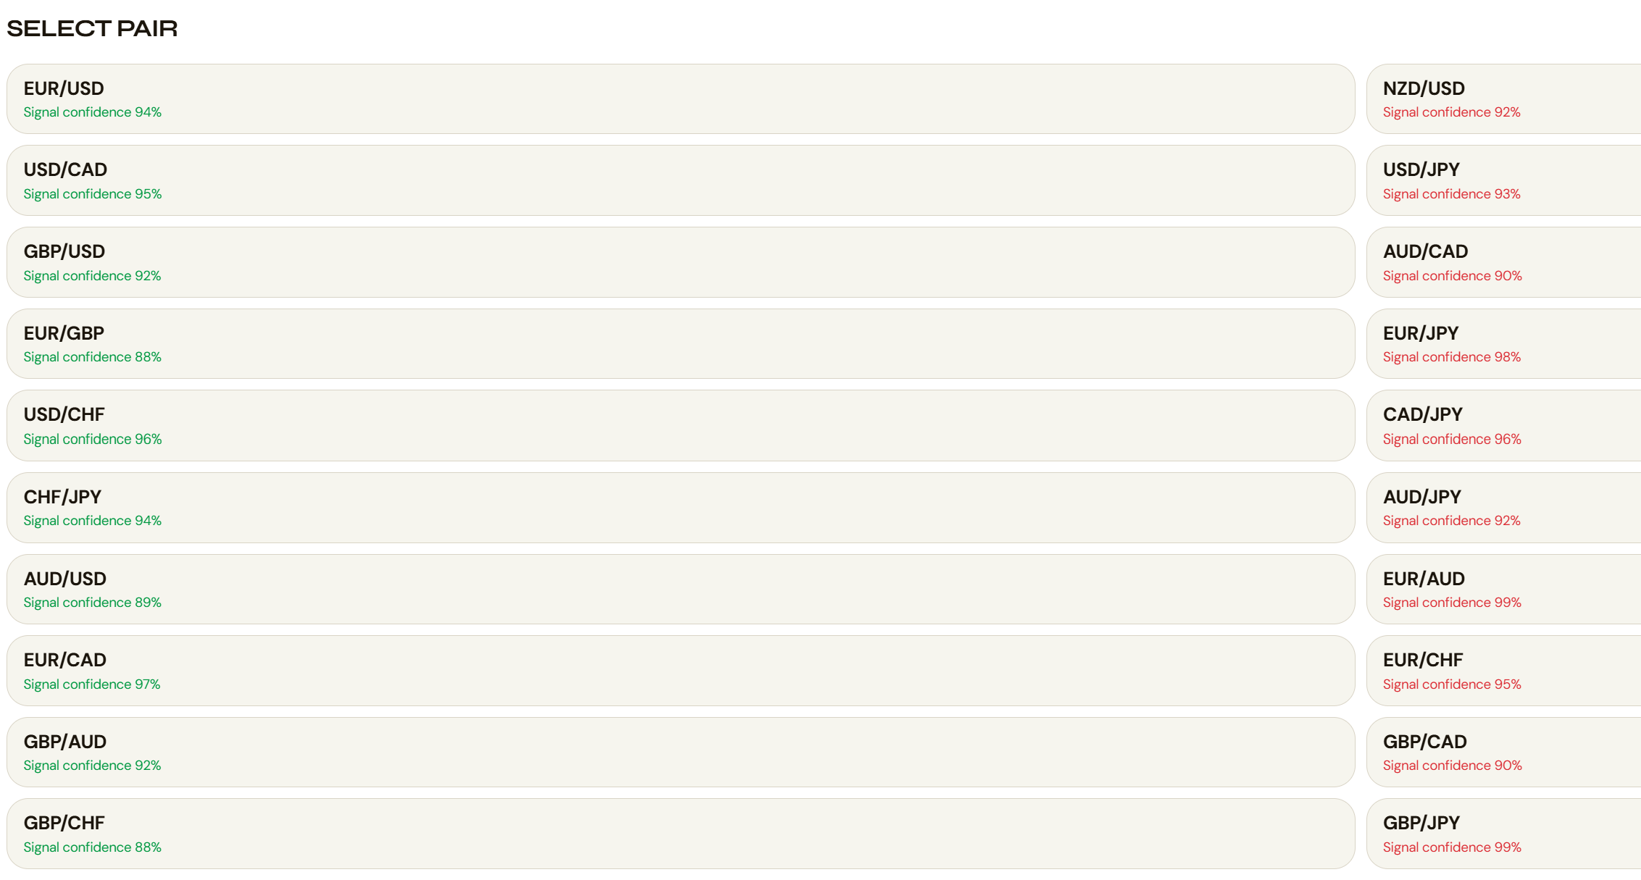
in pairs my
1- XAU/USD
2- BTC/USD
ye dono pairs add krnay hn

7th step
TradoWix ky spelling har jaga si krnay hn

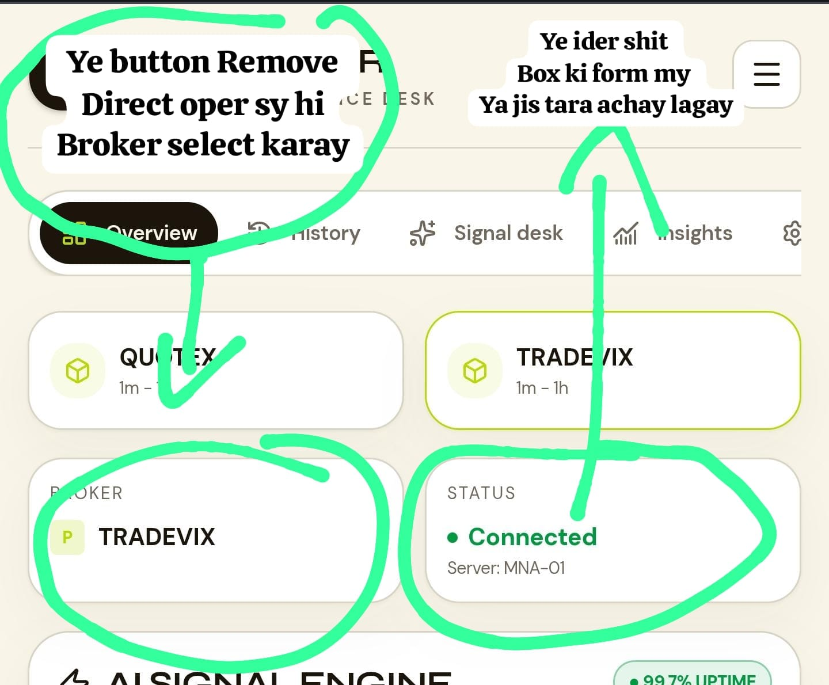
8th step

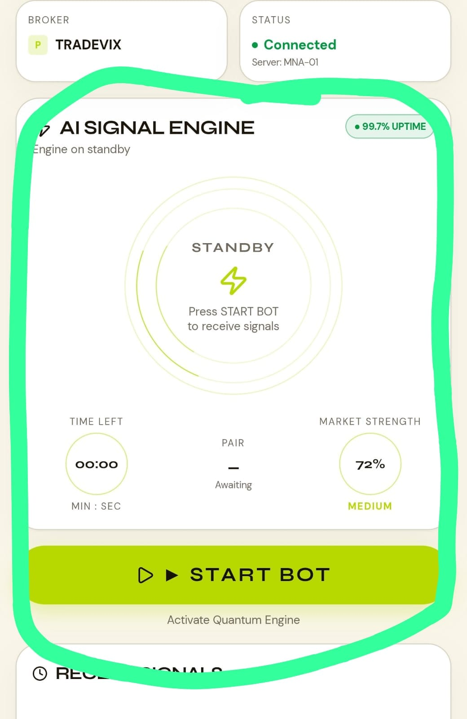
9th step

is box ko bi thora chota kr den takay easily ye 4 5 main chhezay front page pr hi aaa jay page ko neechay krnay ki zarorat na paray
main cheezay maslan sub sy oper 2 box broker ky quotex or tradoWix ka
us ky baad 2sri line my 2 boxes 1 time select krnay wala or currency select krnay wala or koshish krye ga wo dono box same size ky hon matlab same length and weidght or wo bi jab select karay to proper highlight hon
3rd my ye signal create krnay wala box aaa jay baki sub kuch neechay shif kr den agar koi cheez hy

